**Project Design Phase-II**

**Data Flow Diagram & User Stories**

|  |  |
| --- | --- |
| Date | 26-06-2025 |
| Team ID | LTVIP2025TMID43459 |
| Project Name | FlightFinder |
| Maximum Marks | 4 Marks |

***Data Flow Diagrams - Overview:***

### ****Data Flow Diagrams - Overview****

A **Data Flow Diagram (DFD)** visualizes how information flows through the FlightFinder platform, showing interactions between users (travelers, admins) and subsystems like flight search, booking, and payment processing.

**Key Components of Level-0 and Level-1 DFD:**

* **External Entities:** Travelers, Airlines, Payment Gateways.
* **Processes:** Flight Search, Seat Selection, Payment Processing, Booking Confirmation.
* **Data Storage:** MongoDB collections (Users, Flights, Bookings).
* **Data Flow:** Secure transmission of user inputs, flight data, and payment details.
* This helps both developers and stakeholders understand how data travels securely and efficiently within the app.

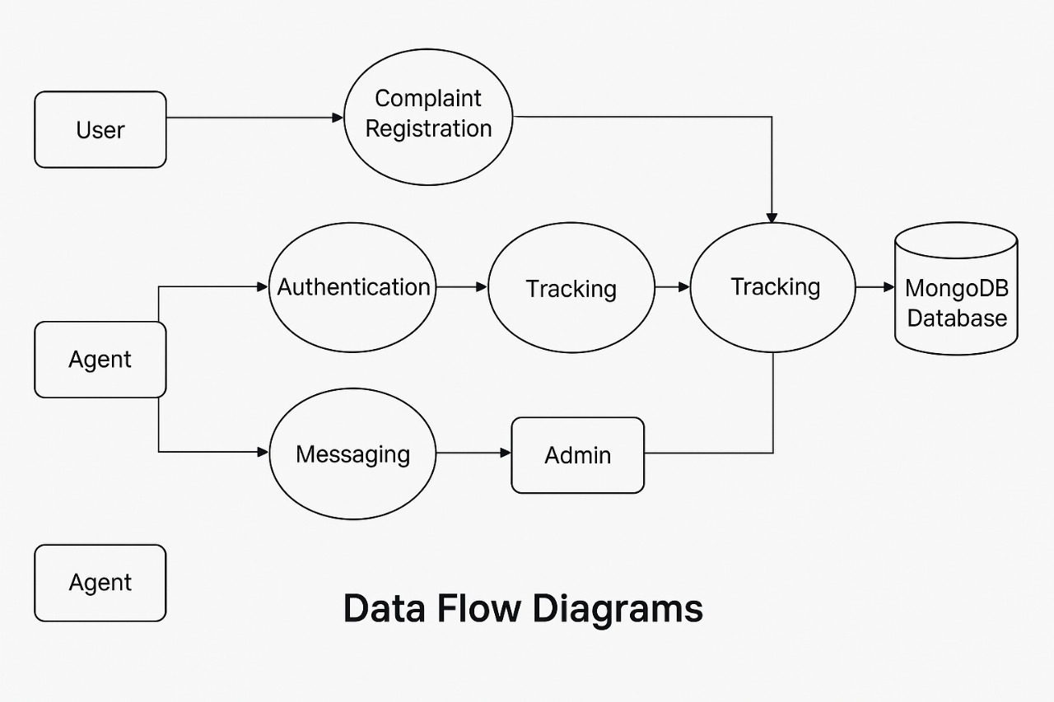

Revised user Story Table – FlightFinder

|  |  |  |  |  |  |
| --- | --- | --- | --- | --- | --- |
| **User Type** | **Functional Requirement (Epic)** | **User Story / Task** | **Acceptance Criteria** | **Priority** | **Release** |
| **User** | |  |  |  | | --- | --- | --- | | |  | | --- | | Complaint  Registration |  |  | | --- | |  | | | |  | | --- | | As a user, I can submit a complaint with  relevant details and attachments. |  |  | | --- | |  | | Booking is saved and  Confirmation is shown | High | Sprint-1 |
| **Agent** | Booking  Management | |  | | --- | | As an Agent, I can view assigned  Complaints and update their status | | Status change is saved and  User is notified | High | Sprint-1 |
| **User** | Booking  Tracking | As a user, I can view the status of my  Bookings in real-time | Status is displayed correctly  Ffrom the database | Medium | Sprint-2 |
| **User + Agent** | Messaging/  Communication | As a user/agent, I can chat in real-time  Within the booking thread. | Messages are visible  instantly to both parties. | Medium | Sprint-2 |
| **Admin** | Booking  Assignment &  Moderation | As an admin, I can assign bookings to  agents and review platform activity (bookings, users). | Assignment is reflected in  agent dashboard. | High | Sprint-1 |

This user story table clearly maps out the expected functionalities of each user role in the FlightFinder platform. Stories are prioritized and distributed across sprints based on complexity and user impact. High-priority features like booking registration, assignment, and tracking are handled in the initial sprint releases to ensure a strong MVP.

Each story is tied to a specific acceptance criteria, helping developers and testers validate completion, while also ensuring alignment with user expectations.